**Kirkby Road Sports Ground**



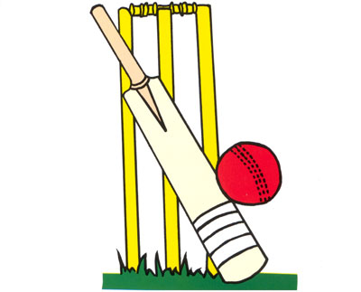

**Barwell Cricket Club**

**Junior & Youth**

**Cricket Practice**

**Friday Evenings – 6.00pm to 7.15pm**

**For boys and girls aged between 5 & 13 to play in our various junior teams.**

**No experience needed, just the ability to join in and have a great time.**

**Interested? Call our Junior Coordinator.**

**Geoff Hines 07722 923662**

**Or email: geoffhinessnr@icloud.com**

[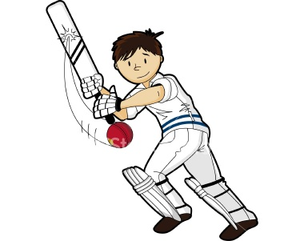](http://www.google.co.uk/url?sa=i&rct=j&q=&esrc=s&source=images&cd=&cad=rja&uact=8&ved=0ahUKEwjzhfLK7IjKAhWD8RQKHWQXBEAQjRwIBw&url=http://www.firstkansas.org/tag/cricket-game/&psig=AFQjCNHGWrYB-rSamFIl_XyuuDuNCP98nQ&ust=1451745680673117)

**www.barwellcc.co.uk**

[](http://www.google.co.uk/url?sa=i&rct=j&q=&esrc=s&source=images&cd=&cad=rja&uact=8&ved=0CAcQjRw&url=http://www.ecb.co.uk/clubmark&ei=Wi4pVd2gEsesUbDZgLAO&bvm=bv.90491159,d.d2s&psig=AFQjCNHunIkdbf70H8W_8KOt8iXMdCQWgw&ust=1428848597514183)

